DTS-TREX User Guide

Issued Date: DEC 20th 2017
Author: Intel DPDK Validation team
Revision History

Date | Revision | Comment
DEC 20th, 2017 | 1.0 | Initial document for release

Contents
Audience and Purpose 4
Prerequisites: 4
Setup TREX 4

Setup DTS 5
Examples: 10
Topology 10
Workflow 10
Launch TREX server 10
Run DTS 11

Audience and Purpose
The primary audience for this user guide are test engineers implementing the Data Plane Development Kit (DPDK) performance test with Trex traffic generator.
The purpose of this document is to guide user to implement DPDK performance test using DTS(DPDK test suite) coupling with traffic generator TREX.

Prerequisites:

Setup TREX
- Download Trex source code, the recommended Trex version to download is 2.26
( http://trex-tgn.cisco.com/trex/release/v2.26.tar.gz )
- Make a directory in /opt: /opt/trex-core-2.26/scripts
- Extract the downloaded TREX tarball in directory /opt/trex-core-2.26/scripts.
- As first time to start trex, now should check if TREX server could be launched with success
  - Select TREX ports
→./opt/trex-core-2.26/scripts/dpdk_setup_ports.py –i
配置port时，改变mac地址那地方说一下
(this action saves the TREX configuration in /etc/trex_cfg.yaml )
  - Start TREX server
→./ opt/trex-core-2.26/scripts/t-rex-64 –i –c 4
(below is a TREX server started successfully with two 25g ports)
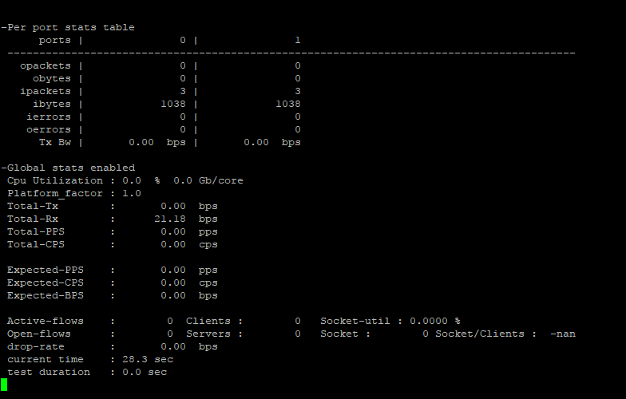

Setup DTS
Please follow below steps to set up and configure a DTS (DPDK test suite) test environment.

- Clone DTS source
  - git clone http://dpdk.org/git/tools/dts
  - Switch to next branch
→git checkout next

- please install following packages required for DTS(assuming the OS is Ubuntu, if you are using different OS other than Ubuntu, please adjust the command to install accordingly)
  - apt-get install python-pexpect
  - apt-get install python-xlwt
  - apt-get install python-xlrd
  - apt-get install scapy
  - apt-get install tcl
  - apt-get install python-prettytable
  - apt-get install python-ipy

- please edit following configuration files for DTS separately
  - Edit file execution.cfg in DTS root directory.
    - Copy “execution.cfg” into DTS root directory by issuing:
- copy execution/executuion.cfg ./ (the content is as follows)
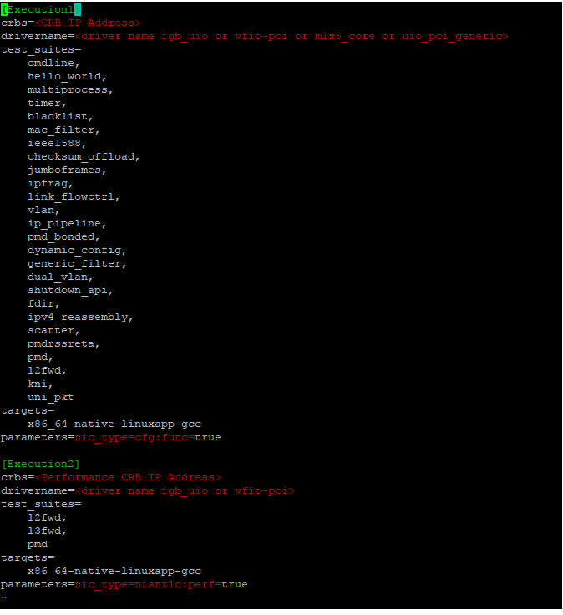
    - vim execution.cfg
→Crbs = “your target DUT IP”
→Test_suites = “your performance test suite will test with Trex ”
→All the remaining fields keep the same with below graph.
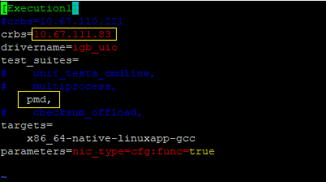

  - vim conf/crbs.cfg (the original content is as follows)
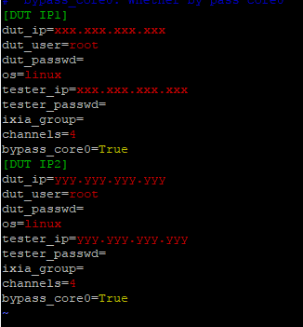
→DUT IP1 = “your target DUT IP”
→dut_ip = “your target DUT IP”
→dut_user = “your target DUT root account”
→dut_passwd = “your target DUT password for root account”
→tester_ip = “ip address for machine running DTS on”
→tester_passwd = “password for tester user account”
After you configured done, the file crbs.cfg should be looked like this:
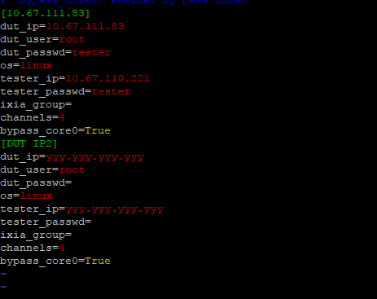

  - Vim conf/port.cfg (the original content is as follows)
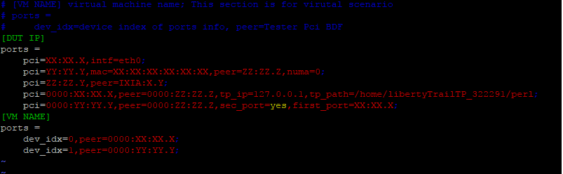
→DUT IP = “your target DUT IP”
→pci=”pci for one dut port”,peer=”TREX port number”
→deregister or remove all pci lines that are not used.
After you edit it done, now the file should be looked like this:
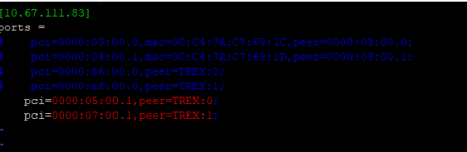

  - Vim conf/pktgen.cfg ( the original content is like as follow):
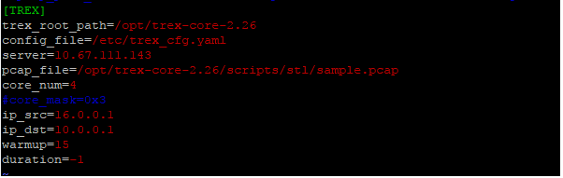
→server = “your trex server IP address”

Examples:
Here is an example to demonstrate the whole process of configuring DTS-TREX and retrieving TREX APIs for performance test, it will show you DTS-TREX work flow and guild you to how to design your test cases scripts using TREX.

Topology
We are using two intel 25G NICs(XXV710) installed on DUT, pick one port for each NIC.
And install the same two NICs on tester, pick one port for each NIC as TREX port
The topology is as follows:
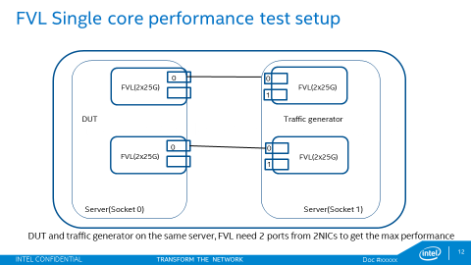

Workflow
This DTS-TREX framework is designed to launch TREX server manually as prerequisite.
So the whole workflow is:
Manually start TREX server → run DTS → Manually stop TREX server

Launch TREX server
- Pre-configure ports for TREX server
→./opt/trex-core-2.26/scripts/dpdk_setup_ports.py –i (select two ports in two 25G NIC)
( this action only need to be conducted when first time to launch TREX server or when the port number or port type need to be changed)
- Manually start TREX server
→./opt/trex-core-2.26/scripts/t-rex-64 –i –c 6

Run DTS
- Configure the required configuration files (conf/port.cfg, conf/crbs.cfg, conf/pkggen.cfg) separately following steps in Setup DTS section.They are:

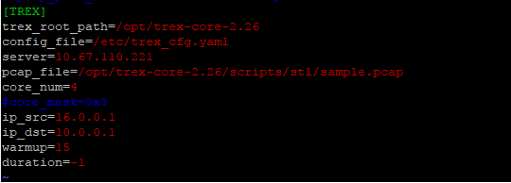

- Instruction to design code to retrieve TREX APIs in your test suite.
  - set TREX transmit and receive ports
→ txport0 = self.tester.get_local_port(self.dut.get_ports()[0])
→ rxport0 = self.tester.get_local_port(self.dut.get_ports()[0])
→txport1 = self.tester.get_local_port(self.dut.get_ports()[1])
→rxport1 = self.tester.get_local_port(self.dut.get_ports()[1])
  - Add in two streams for ports:
→stream_id0 = self.tester.pktgen.add_stream(txport0, rxport1, ‘pcap file')
→stream_id1 = self.tester.pktgen.add_stream(txport1, rxport0, ‘pcap file')
（the pcap file was created by scapy that contains basic packet information ,that could be mac address and IP address）
  - Configure streams:
→options = {
'rate' : '100%',
'ip': {'action': 'inc', 'mask' : '255.255.255.0', 'step': '0.0.0.1'}
}
(Option ‘rate’: to configure traffic sending percentage
Option ‘ip’： to configure IP address increment or decrement action, and mask and step)
→self.tester.pktgen.config_stream(stream_id0, options)
→self.tester.pktgen.config_stream(stream_id1, options)
  - Now TREX are ready to send traffic, and start app testpmd waiting for traffic coming in
→testpmd> start

  - Start sending traffic from TREX.
→ bits_received, packets_received = self.tester.pktgen.measure_throughput(stream_ids=[stream_id0, stream_id1],delay)
(delay: the traffic lasts,
bits_received: all bits received within the period delay,
packets_received: all packets received within the period delay
)

- Close TREX server manually after DTS run completed:
→^c ( make sure in “/opt/trex-core-2.26/scripts/t-rex-64 –i –c 6” console session)

DISCLAIMERS
INFORMATION IN THIS DOCUMENT IS PROVIDED IN CONNECTION WITH INTEL PRODUCTS. NO LICENSE, EXPRESS OR IMPLIED, BY ESTOPPEL OR OTHERWISE, TO ANY INTELLECTUAL PROPERTY RIGHTS IS GRANTED BY THIS DOCUMENT. EXCEPT AS PROVIDED IN INTEL'S TERMS AND CONDITIONS OF SALE FOR SUCH PRODUCTS, INTEL ASSUMES NO LIABILITY WHATSOEVER AND INTEL DISCLAIMS ANY EXPRESS OR IMPLIED WARRANTY, RELATING TO SALE AND/OR USE OF INTEL PRODUCTS INCLUDING LIABILITY OR WARRANTIES RELATING TO FITNESS FOR A PARTICULAR PURPOSE, MERCHANTABILITY, OR INFRINGEMENT OF ANY PATENT, COPYRIGHT OR OTHER INTELLECTUAL PROPERTY RIGHT.
You may not use or facilitate the use of this document in connection with any infringement or other legal analysis concerning Intel products described herein.
Tests document performance of components on a particular test, in specific systems. Differences in hardware, software, or configuration will affect actual performance. Consult other sources of information to evaluate performance as you consider your purchase. For more complete information about performance and benchmark results, visit www.intel.com/benchmarks.
Software and workloads used in performance tests may have been optimized for performance only on Intel microprocessors. Performance tests, such as SYSmark and MobileMark, are measured using specific computer systems, components, software, operations and functions. Any change to any of those factors may cause the results to vary. You should consult other information and performance tests to assist you in fully evaluating your contemplated purchases, including the performance of that product when combined with other products.
For more information go to http://www.intel.com/performance
Intel® AES-NI requires a computer system with an AES-NI enabled processor, as well as non-Intel software to execute the instructions in the correct sequence. AES-NI is available on select Intel® processors. For availability, consult your reseller or system manufacturer. For more information, see http://software.intel.com/en-us/articles/intel-advanced-encryption-standard-instructions-aes-ni/
Copyright © 2026 Intel Corporation. All rights reserved.

